How to Debug power consumption

check which power off function should use
- If used 32k XTAL, use HAL_PMU_EnterShutdown() to power off, it will switch to rc10k in this function
If a 32K crystal is not used, use HAL_PMU_EnterHibernate() to power off， always use rc10k

after enter Hibernate, all GPIO pin no electric leakage except WKUP pin

DEEPSLEEP、LIGHTSLEEP、STANDBYSLEEP can also be used as a shutdown(standby shutdown). Before the CPU goes to sleep, turn off all storage such as PSRAM and flash, as well as sensor power.
In these three modes, all regular GPIOs do not lose power. Be aware of potential leakage. Floating pins are recommended to be configured as Analog. Pins controlling power are recommended to be configured with PIN_PULLDOWN.
After the power is turned off, the corresponding sensor communication ports also need to be configured, otherwise backflow current may occur.

The wake-up pin must have a stable voltage level。Software internal pull-down or Hardware external pull-down

PB54 #WKUP_PIN0
PB55 #WKUP_PIN1
PB56 #WKUP_PIN2
PB57 #WKUP_PIN3
PB58 #WKUP_PIN4
PB59 #WKUP_PIN5

PA64 #WKUP_PIN6
PA65 #WKUP_PIN7
PA66 #WKUP_PIN8
PA67 #WKUP_PIN9
PA68 #WKUP_PIN10
PA69 #WKUP_PIN11

PBR00~PBR05

The default design may use pbr0 to control the power of psram。
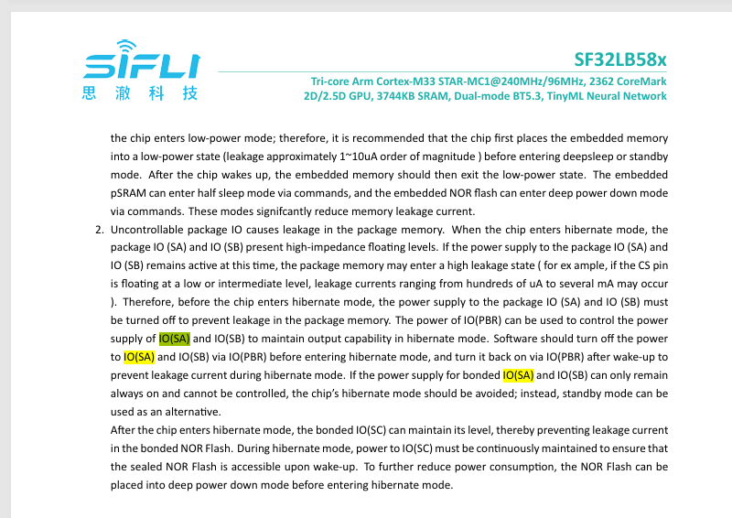
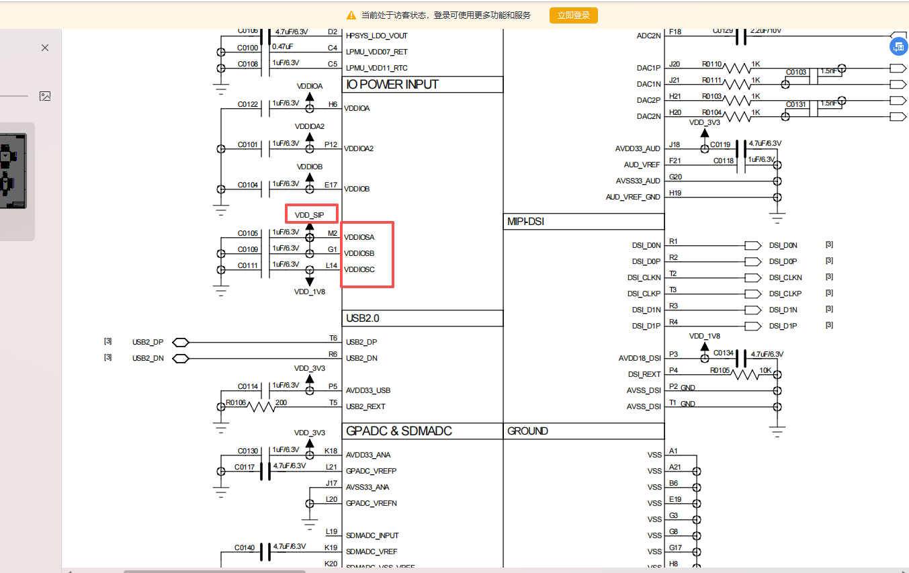

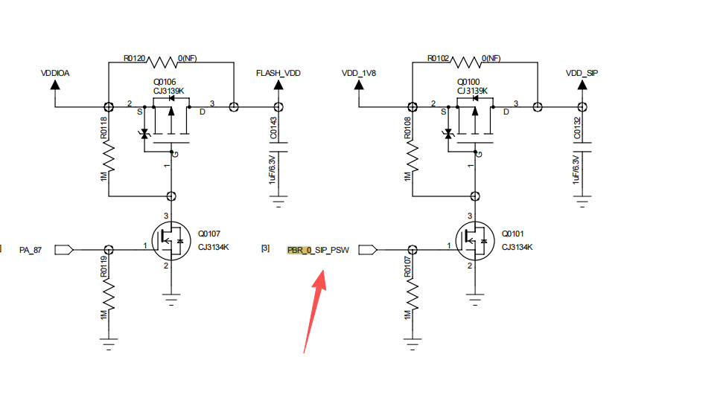

should disalbe VDD_SIP_ON, power off this PIN。

VDDIOSC is internal nor flash，It is designed to maintain long-term power supply. There is no problem with the design.

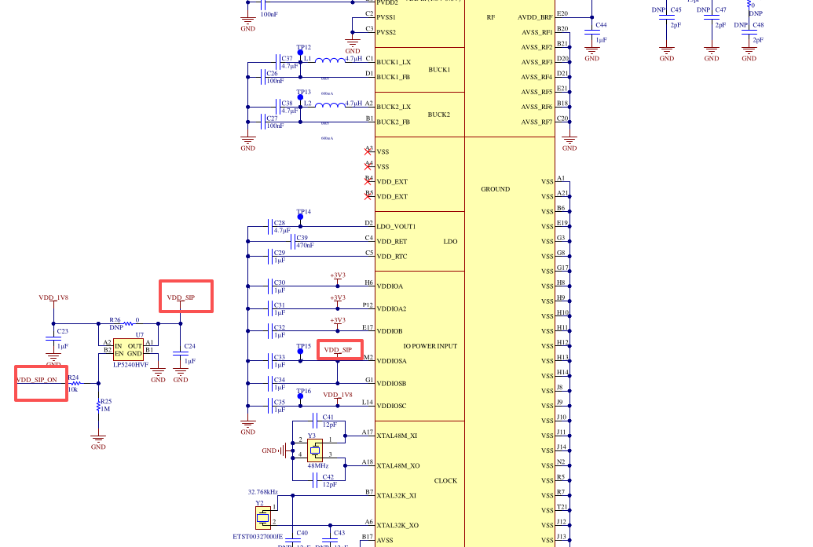

check hardware test point on the board
- To confirm whether the HCPU and LCPU are in normal sleep mode, you can check following hardware test point on the board:
- HPSYS_LDO_COUT
- BUCK2_COUT
- VDD_RET
- VDD_RTC

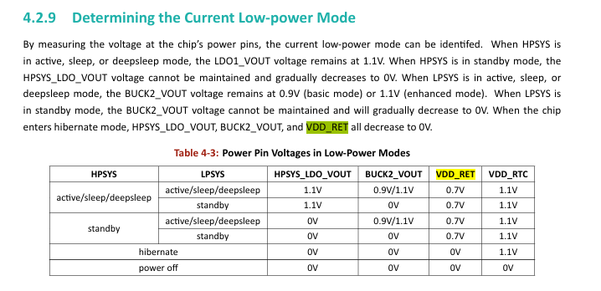

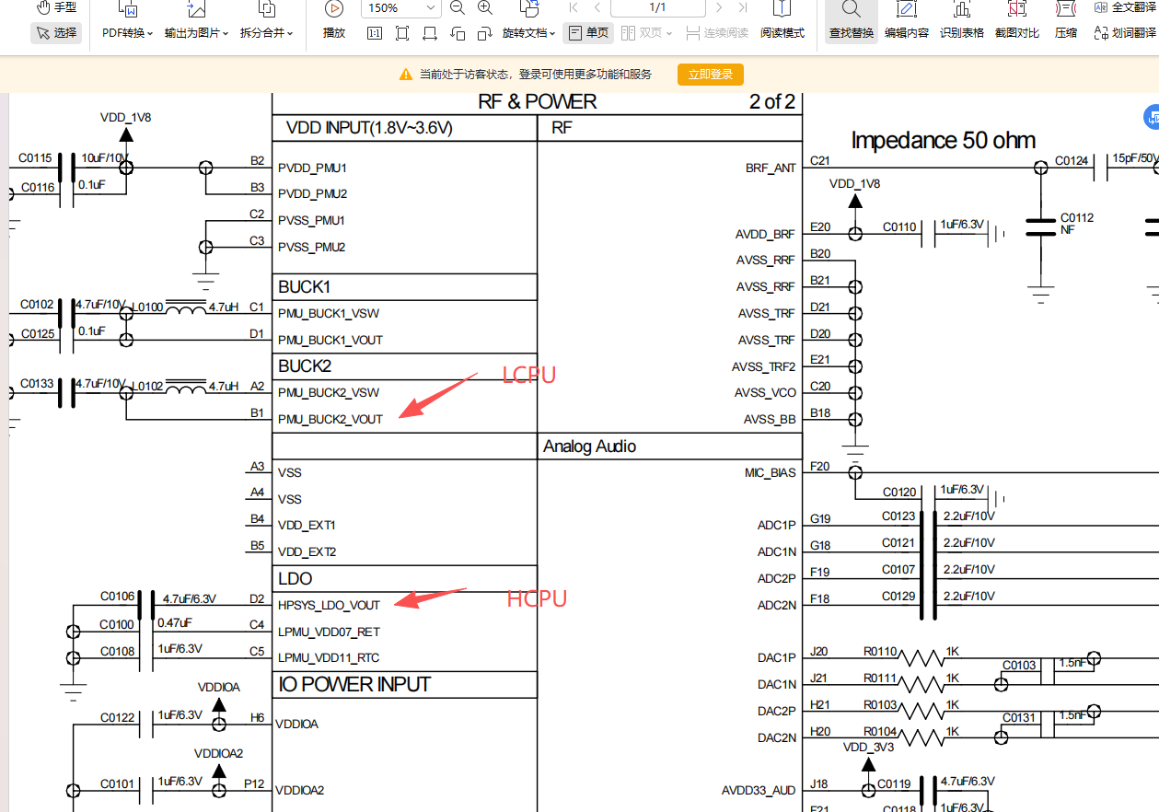

Potential issues in your code
why reconfig gpio？
changed the default wkup pin?

compare main-fixed_v01.c with your main.c
we fixed self_config_set_wkup_pin_pulldown()。
config all wkup pin to software internal pull down

